Mathematical Statement

🌟 Definition
# Source: AI Source: Provided by: [Data Path: Persons Table -> ID Column: 1, Name_En Column: Motasem Essam] -> From: [ChatGPT] on [5/29/2026]
A mathematical statement is a meaningful sentence in mathematics that expresses a claim, relation, or fact, and can be judged as true or false.
It is the basic unit used in mathematical logic and reasoning.

🎯 Purpose of a Mathematical Statement
# Source: AI Source: Provided by: [Data Path: Persons Table -> ID Column: 1, Name_En Column: Motasem Essam] -> From: [ChatGPT] on [5/29/2026]
- To express mathematical ideas clearly
- To form the basis of proofs and logic
- To state facts, conditions, or relationships
- To allow reasoning about truth and falsehood
- To build the foundation of mathematical theories

📚 Key Characteristics
# Source: AI Source: Provided by: [Data Path: Persons Table -> ID Column: 1, Name_En Column: Motasem Essam] -> From: [ChatGPT] on [5/29/2026]
A mathematical statement:
- Has a definite meaning
- Can be either true or false
- May contain variables or constants
- Can be simple or complex
- Is used in logic, proofs, and theorems

🧩 Types of Mathematical Statements

1. Simple Statement
# Source: AI Source: Provided by: [Data Path: Persons Table -> ID Column: 1, Name_En Column: Motasem Essam] -> From: [ChatGPT] on [5/29/2026]
A statement with no variables.
Example:
$$2+3=5$$

2. Compound Statement
# Source: AI Source: Provided by: [Data Path: Persons Table -> ID Column: 1, Name_En Column: Motasem Essam] -> From: [ChatGPT] on [5/29/2026]
A statement formed by combining two or more statements using logical connectors.
Example:
$$\left(2+3=5)∧(4>1\right)$$

3. Open Statement
# Source: AI Source: Provided by: [Data Path: Persons Table -> ID Column: 1, Name_En Column: Motasem Essam] -> From: [ChatGPT] on [5/29/2026]
A statement with variables whose truth depends on the values.
Example:
$$x+2=5$$
- True when x = 3
- False for other values

4. Conditional Statement
# Source: AI Source: Provided by: [Data Path: Persons Table -> ID Column: 1, Name_En Column: Motasem Essam] -> From: [ChatGPT] on [5/29/2026]
A statement of the form “If…then…”
Example:
$$x>5⇒x>2$$

✏️ Examples of Mathematical Statements
# Source: AI Source: Provided by: [Data Path: Persons Table -> ID Column: 1, Name_En Column: Motasem Essam] -> From: [ChatGPT] on [5/29/2026]
- 7 is a prime number (true)
- 10 < 3 (false)
- x + 1 = 6 (open statement)
- If a number is even, then it is divisible by 2 (true)

🔗 Relationship to Other Concepts
# Source: AI Source: Provided by: [Data Path: Persons Table -> ID Column: 1, Name_En Column: Motasem Essam] -> From: [ChatGPT] on [5/29/2026]
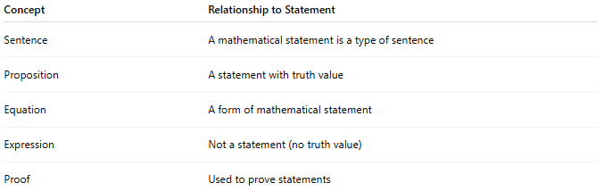
Concept | Relationship to Statement
Sentence | A mathematical statement is a type of sentence
Proposition | A statement with truth value
Equation | A form of mathematical statement
Expression | Not a statement (no truth value)
Proof | Used to prove statements

📖 Statement vs Sentence vs Expression
# Source: AI Source: Provided by: [Data Path: Persons Table -> ID Column: 1, Name_En Column: Motasem Essam] -> From: [ChatGPT] on [5/29/2026]
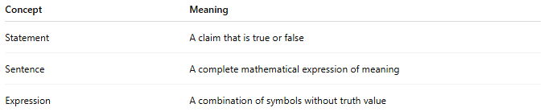
Concept | Meaning
Statement | A claim that is true or false
Sentence | A complete mathematical expression of meaning
Expression | A combination of symbols without truth value
Example:
- Expression: $x+3$
- Statement: $x+3=7$
- True statement: $5+2=7$

🧠 Simple Analogy
# Source: AI Source: Provided by: [Data Path: Persons Table -> ID Column: 1, Name_En Column: Motasem Essam] -> From: [ChatGPT] on [5/29/2026]
A mathematical statement is like a claim in a debate:
- It says something clearly
- It can be tested for truth
- It is used in arguments and proofs

🧭 Summary
# Source: AI Source: Provided by: [Data Path: Persons Table -> ID Column: 1, Name_En Column: Motasem Essam] -> From: [ChatGPT] on [5/29/2026]
A mathematical statement is a meaningful mathematical claim that is either true or false. It is a fundamental part of mathematical logic and is used in equations, proofs, and reasoning.

